SOUTH HOLLAND SCHOOL DISTRICT 150 HEALTH AND WELLNESS RESOURCES

This is a brief listing of some of the providers available in and near South Holland which is intended to connect residents with community assets, provide information about resources to improve quality of life, and offer access to information for residents who are in need of services. You are encouraged to research and determine the best provider for your family. South Holland School District 150 accepts no liability for the content of these resources, or for the consequences of any actions taken on the basis of the information provided. Note: It’s our goal to provide current and accurate information; however, businesses may have changed locations or contact information.
South Holland School District 150 does not endorse any provider nor evaluate the quality of service provided.

Actionable Resources ~ Take Immediate Action
Nationwide Suicide Hotline | Available 24/7 | 800-273-8255 | www.suicidepreventionlifeline.org
SASS-Screening, Assessment, and Support Services | Call to request a screening when someone is engaging in self harm or has suicidal thoughts or ideations. | 800-345-9049 | www.dhs.state.il.us
Thornton Township | General assistance and foods bank information | 708-596-6040 | www.thorntontownship.com
Homeless Shelter directory  of food banks | A list of food banks within the areas |  | South Holland Emergency Food Pantries, Soup Kitchens ...www.homelessshelterdirectory.org › cgi-bin › cityfoodbanks › city=S...
Link and Option Center, Inc | Local substance abuse and mental health counseling | 708-331-8111 | 924 E. 162nd Street, Suite A  South Holland, IL
Restoration Ministries | Food bank, clothing, furniture | 708-333-3370 | 253 E. 159th Street, Harvey, Illinois  www.restorationministries.net
SAMHSA-Substance Abuse and Mental Health Services | Online Treatment Locator-call to find local agencies that provide counseling | 800-662-4357 | www.samhsa.gov
Self Harm Hotline | Available 24/7 | Text CONNECT to 741741 | www.crisistextline.org
Kids Health Org. | Helping teens who cut - Help for parents and teens | Type Cutting or self harm in search bar | www.kidshealth.org

Home Social Emotional Learning Resources for Parents

 | Suite 360- Social Emotional  Digital Character Development | www.shsd360.org
Conscious Discipline  Primary Grades | Resources to handle the upset and conflict that comes your way | https://consciousdiscipline.com/about/parents/  https://consciousdiscipline.com/free-resources/
Go Noodle | Mindfulness and Movement Breaks | www.gonoodle.com
CASEL | CASEL  SEL Resources for Families | https://casel.org/covid-resources/
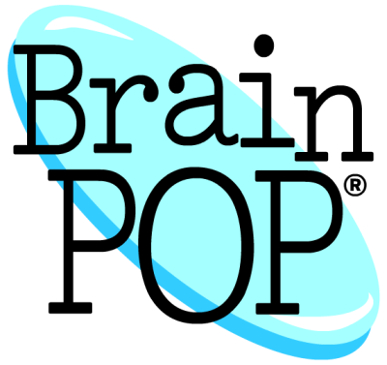 | Free Access to Mental Health Resources | https://www.brainpop.com/health/
Common Sense Media | Social/Emotional Learning  SEL Resources for Families | https://www.commonsense.org/education/toolkit/social-emotional-learning
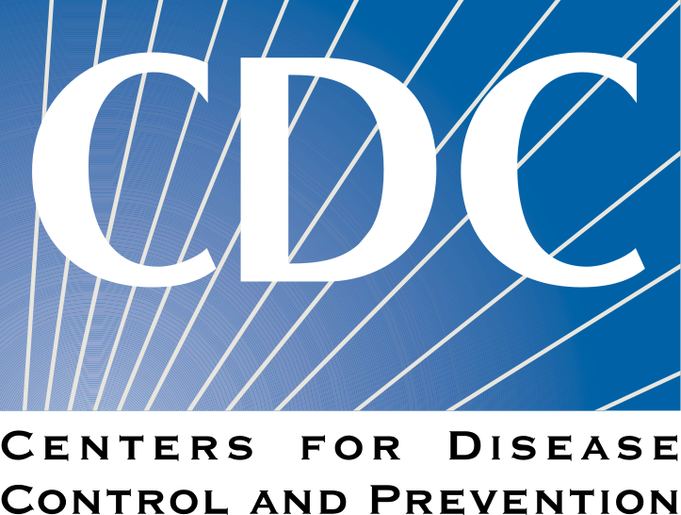 | CDSC - Caring for Children in a Disaster | https://www.cdc.gov/childrenindisasters/helping-children-cope.html
Calm | Supporting Mental and Emotional Wellness | https://www.calm.com/blog/take-a-deep-breath?utm_source=lifecycle&utm_medium=email&utm_campaign=difficult_times_nonsubs_031720
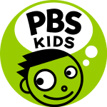 | How to talk to Kids About Coronavirus | https://www.pbs.org/parents/thrive/how-to-talk-to-your-kids-about-coronavirus
Healthy Children | Talking to Children About News Events | https://www.healthychildren.org/English/family-life/Media/Pages/Talking-To-Children-About-Tragedies-and-Other-News-Events.aspx
Emotional ABC’s | Empowering Children with Better Emotional Skills | www.emotionalabsc.com

Parent University Online Resources for Families
 | The Essential Building Blocks of Resilience | http://www.fosteringresilience.com/7cs.php
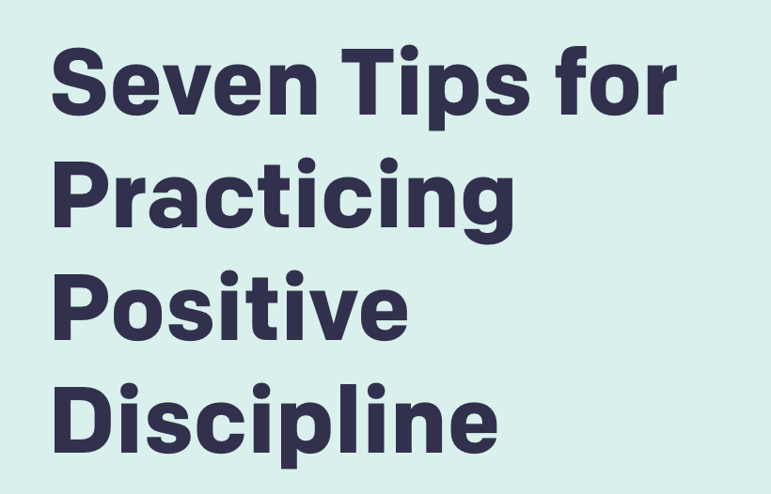 | 7 Tips for Practicing Positive Discipline | https://www.pbs.org/parents/thrive/seven-tips-for-practicing-positive-discipline
 | Social Emotional Learning Online Classes for Parents | www.shsd360.org

